**The News Monitor Library Tutorial:**

The News monitor research library is a comprehensive, multi-publication SA print media database. It comprises of a research facility, coupled with the daily email alert system which puts our users in the position of receiving a tailor-made, unique stream of information.

The database is sourced from mainstream print media coverage in South Africa (Publications list) and contains articles on every listed company, industry and socio-political issue. These articles are stored in their original format (including pictures) and presented in a user-friendly way with full email and print functionality. The database starts from January 2005 and contains approximately 1, 5 million articles.

To access the database, please use the following URL: <http://www.newsmonitor.co.za/>

Once logged in, you’ll come to the member’s home page – displaying the main sections of the database:

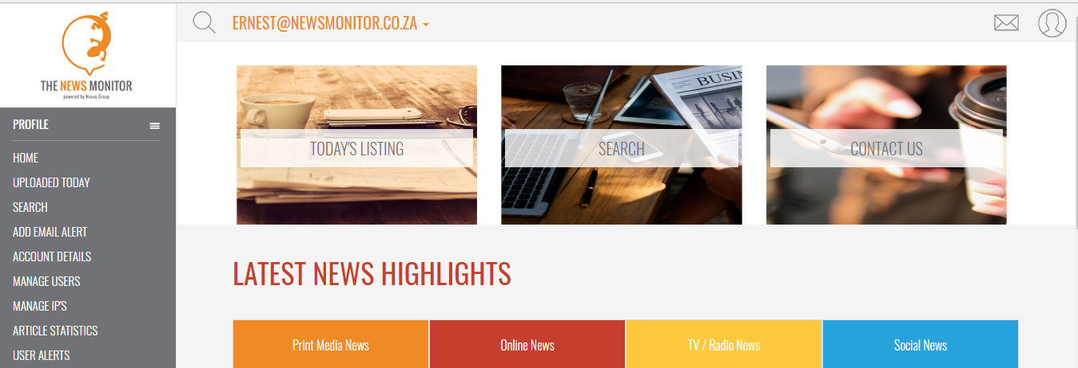

**Uploaded today:**

Refers to the news uploaded on that particular day – articles are listed in chronological order with latest news appearing at the top of the page:

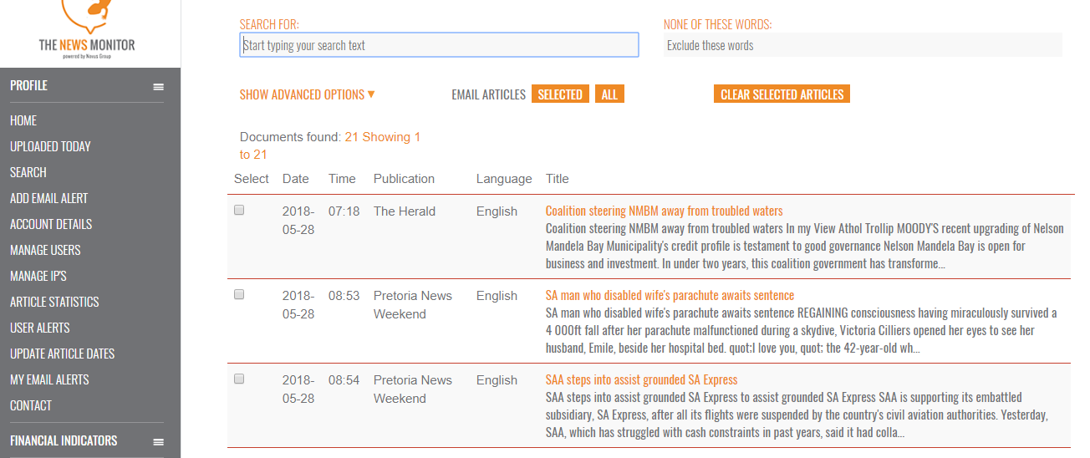

**The Search Engine**

The search engine is the backbone of the database – a user can run anything from simple one-word searches to very detailed key phrases.

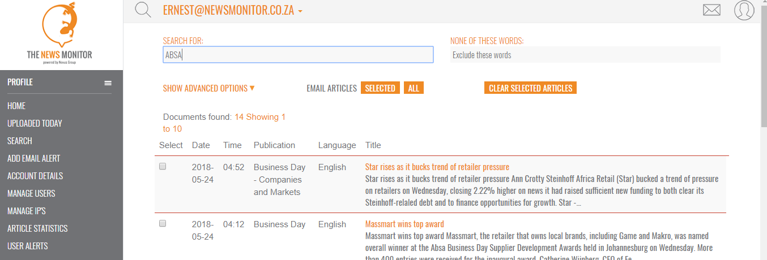

Search results are indicated as above – by clicking on the headline - users will be able to access the actual article. The benefit of using the search engine is that one can ensure that ALL mentions of the keyword in the database, within the desired date range are found. Another benefit of using the search engine is that the keyword is highlighted within the text of the article – as shown below:

**Advanced Search**

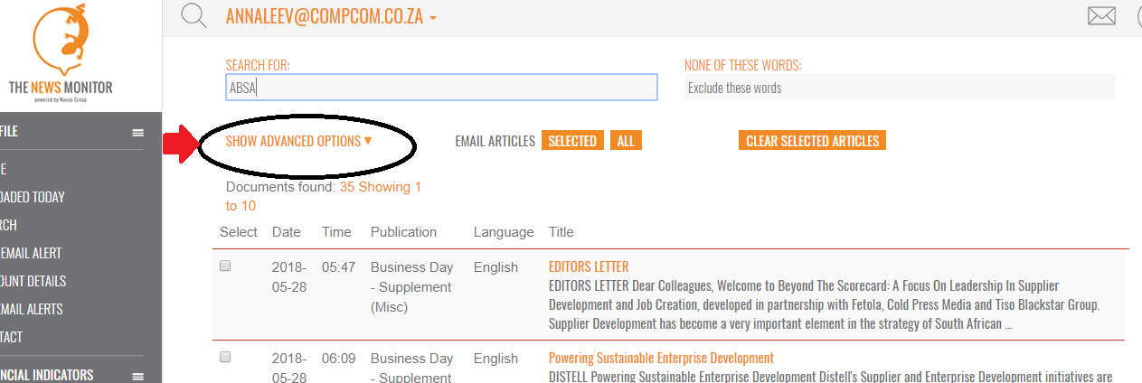

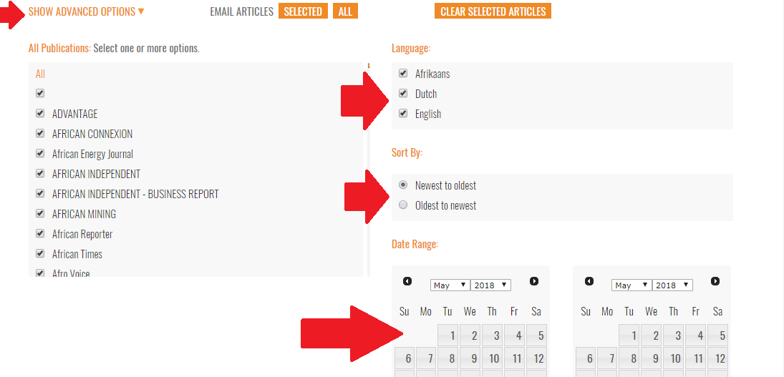

**Bulk Emailing**

Check-boxes allow for multiple articles to be selected for bulk email functionality. Reverting back to the example list of search results:

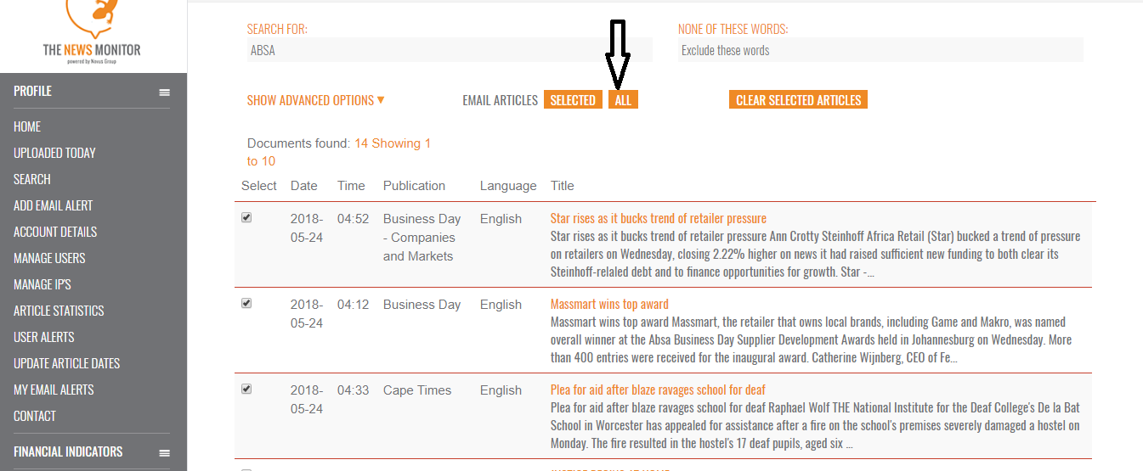

After selecting the relevant articles, the links can be emailed directly to a recipient’s inbox:

**Daily Email Alerts**

This section enables users to set up customized profiles of keywords that, when found on the database, are automatically emailed to the user’s inbox.

The email alerts interface is very user-friendly:

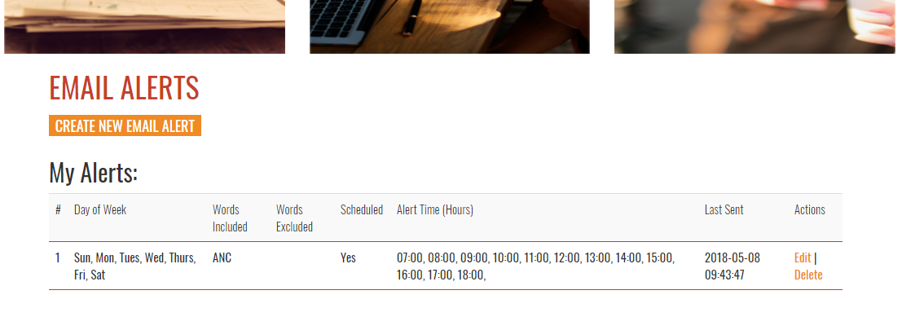

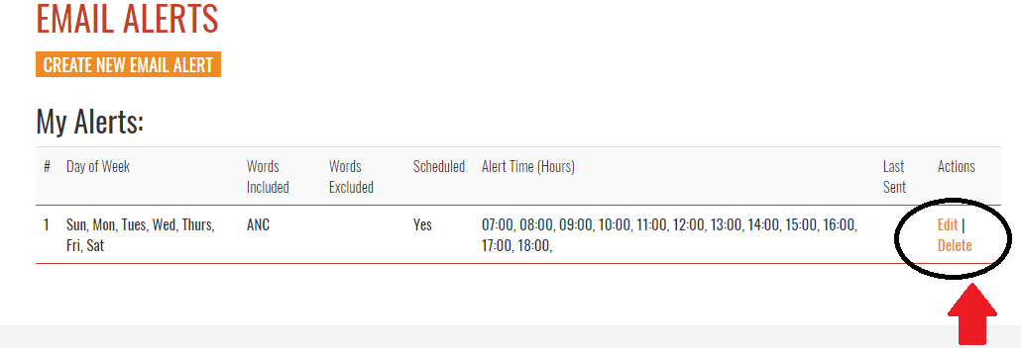

Users can easily add and delete keywords as indicated above. There is no limit to the number of keywords in a profile – however, discretion should be used to avoid email overload.

Previously received alerts are also automatically archived in the interface.

Adding alerts is a very simple process:

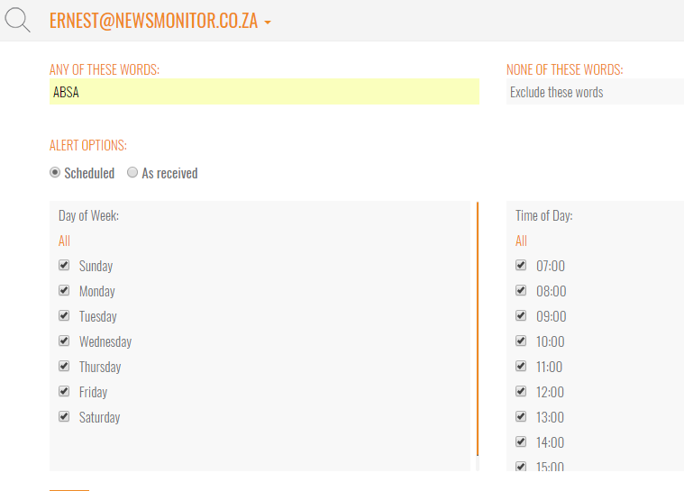

From the point that a keyword/search string is added, the database will send relevant results to the user’s inbox at the delivery frequency chosen – alerts are delivered in the following format:

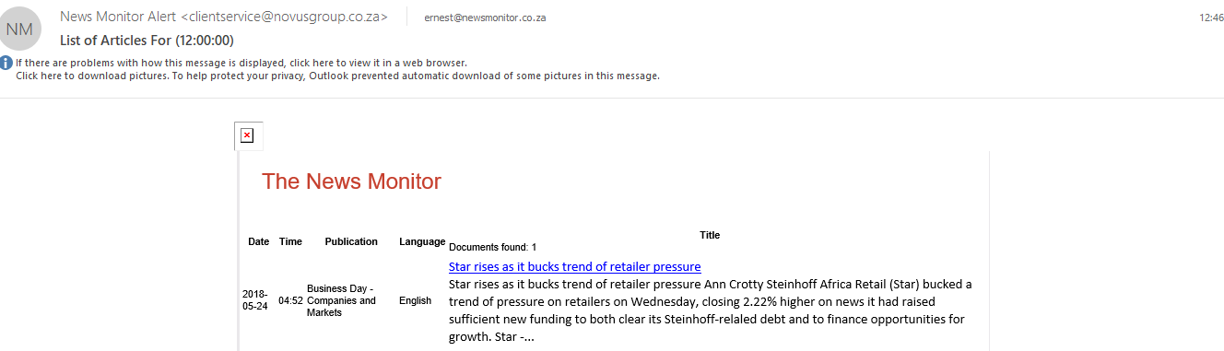

By clicking on the links, users are taken directly to the article:

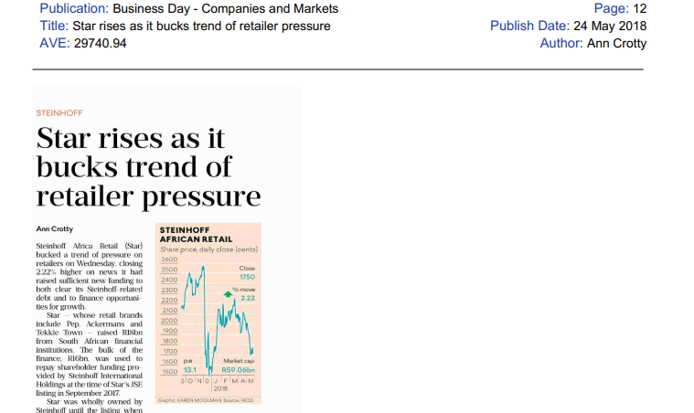

**The End.**